Instructions: Fill up the required information: name and student ID.

For multiple choice highlight the correct option.

After completing all the questions save the file and submit.

Name: Student ID:

**Section - 1**

Multiple choice questions: Chose the correct answer. Each correct answer worth 1 point.

1. If there are multiple start condo, how can you identify the real start codon?
2. By observing Okazaki fragments
3. By identifying splicing site
4. Using sequence data bases
5. By identifying Kozak sequence
6. Which one is not a part of the transcription unit?
7. RNA primase
8. Promoter
9. RNA coding sequence
10. Terminator
11. A mutation that does not alter the amino acid is called a ____
12. Silent mutation
13. Inversion mutation
14. Deletion mutation
15. Frameshift mutation
16. In secondary structure of protein__________
17. Only the amino acid sequence is present
18. Alpha helix is present
19. β-sheet is present
20. Both b & c
21. DNA is made of two strands that are antiparallel. If one strand runs from 3’ to 5’ direction the other one will go from 5’ to 3’ direction. **During replication or transcription, whatever the process is, it will always follow the 5’ to 3’ direction** using the 3’ to 5’ directed strand as the template strand. Therefore, if following is the DNA sequence

5’-CCG ATC GCA CAA-3’

1. Using this sequence as template after transcription no protein can be translated. Why?
2. Presence of start codon
3. Absence of start codon
4. Due to mutation
5. If you want to start the translation, what change you need in the second codon (from 5’ to 3’ direction)?
6. Substitution of C with G
7. No change
8. Deletion of C
9. Both I & III
10. Refer to the figure answer the following questions.

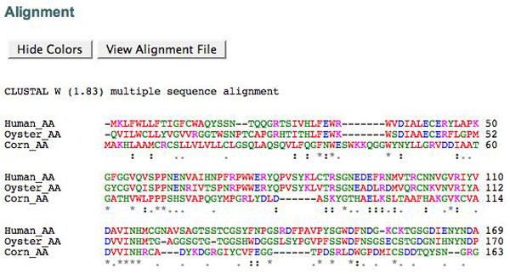

Figure: Sequence alignment

1. How many different species are used as the source of sequence in this analysis?
2. two
3. one
4. three
5. four
6. What does the (*) mark mean in this alignment result?
7. Evolutionarily conserved region in all the sample
8. Evolutionarily not conserved
9. Similar type of amino acid is present
10. A triplet of mRNA is called a?
11. anticodon
12. peptide
13. amino acid
14. codon
15. Original: ATTTGAGCC

Mutated: ATTGAGCC. This is an example of what kind of mutation?

1. Inversion
2. Insertion-Frameshift
3. Deletion-Frameshift
4. All of them

Section-2

Definitions: Write the definition (Briefly in the box) of the following terms. Each definition worth 2 points.

1. Open Reading Frame:
2. Molecular Evolution:
3. Bioinformatics:
4. Missense mutation:
5. Transcriptome:

Section-3

Critical Thinking: Answer the following questions using proper logic. Each question worth (2+4+4) 10 points.

1. Following is an mRNA sequence reported in data base.

5’ ACC AGA ATG ACC ATG GCA 3’

1. There are two ATG’s. From which the translation can be initiated.
2. 1st ATG
3. 2nd ATG
4. None
5. If there are multiple possible start codons, how can you identify the original start codon? Explain.

Your Answer:

1. This is an mRNA sequence, but why there are T’s instead of U’s? Explain.

Your Answer:

Section-4

Database usage test. This task worth 10 points.

1. Go to the website of Protein data bank (<https://www.rcsb.org/>) and search for COX-1 and COX-2 protein. Get the FASTA sequence of both. Open <https://www.ebi.ac.uk/Tools/msa/clustalo/> in another tab for sequence alignment. Use the FASTA sequences for alignment sequence. Take a screen shot of the analysis and paste here.